- Reference : Cell Engineering Lab. IGC NENU
Culturing pyramidal neurons from the early postnatal mouse hippocampus and cortex. Nature Protocols ,79 ,1741-1754 (2012)

Primary Hippocampal Neuron Culture

- Reagents
Poly-L-lysine | Sigma # | P2636
DMEM/F12 Medium | GIBCO # | 11320-033
FBS
Neurobasal Medium | GIBCO # | 21103-049
B-27 supplement | GIBCO # | 17504-044
Trypsin, 0.125% | GIBCO # | 15090-046
L-glutamine | GIBCO # | 16285
Hibernate A Medium | GIBCO # | 1247601
- Equipment.
Dissecting forceps, Dissecting scissors
12-well plate
Round glass coverslips
100mm culture dishes
Stereomicroscope (SFC-11,Motic)
Cell strainer with 70um mesh
Hemacytometer for couting cells
1.5ml and 50ml centrifuge tubes
Graduated tubes ,Pasteur pipettes
Transferpettor (1ml, 200ul, 10ul)
Water bath at 37℃,
Low-speed centrifuge at room temperature,
Culture incubator at 37 ℃ with humidified 5% co2 (S/N43801-3140, ThermoForma),
Ordinary light microscope,
Fluorescent microscope (eclips TE2000-U, Nikon),
Inverted fluorescence microscope (80i, Nikon),
Confocal microscope (FV1000, OLYMPUS)
Safety Instructions
1. All biological materials should be handled and discarded as potentially bio-hazardous.
2. Personal protective equipment such as lab coats, gloves (nitrile), and surgical masks are necessary in experiments for safety reasons.
3. If chemical spill, chemical spill kit is available in safety shelf in E-765, if necessary, please contact lab emergency: 368-3333, lab safety services: 368-2907.

Overview of the technique
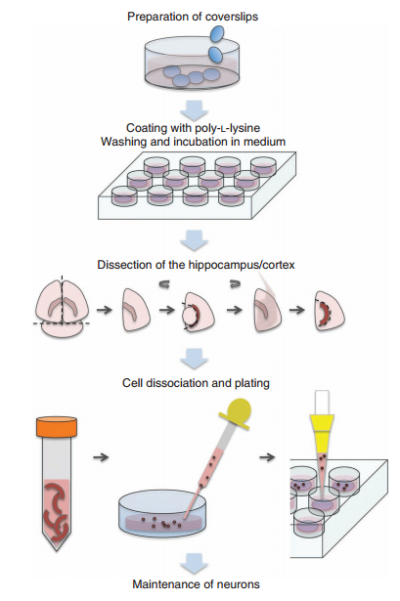

Coverslips are treated, prepared andcoated with poly-l-lysine. After washing, they are incubated in medium. Hippocampi or cortices are dissected; cells are trypsinized and dissociated, and plated on coverslips. The neurons are maintained in culture for up to 28 d.
Before experiment
Preparation of coverslips ● timing 2 d or 5 d before culture
- Place coverslips in a heat-resistant glass container with a large surface area. Add concentrated nitric acid (70% (wt/wt)).
Swirl coverslips in the acid, cover them well and leave them in acid for at least 12 h. The acid can be reused two or threetimes, although it becomes discolored by exposure to light.
Caution: Nitric acid should be handled in a fume hood.
2. Remove the nitric acid and rinse the coverslips four or five times in several volumes of double-distilled water. Afterward, for each wash, allow the coverslips to soak in water for 2 h, before replacing the wash with fresh water. At each wash, swirl the coverslips around carefully.
Coating of coverslips, time-lapse dishes and petri dishes with poly-l-lysine ● timing 1 h or 2 d before culture
1. When working in a sterile laminar hood, use sterile forceps to place individual coverslips in single wells in a 12-well dish.
2. Sterilize by placing the open dishes with the coverslips under ultraviolet light for 30 min.
3. Add enough poly-l-lysine solution to cover the coverslip and the glass bottom of the time-lapse dishes. Incubate in 37°overnight.
4. Add 1 ml of sterile water into each well and aspirate; repeat this step
Three times.
Caution : Ensure that the glass surface does not dry out during the washing procedure
- Sterilize the dissection tools by soaking in 75% alcohol about half an hour.
- Procedure：
- Isolation of the Hippocampal Neuron
- Separate heads from E16-18 mice.
- Prepare one 100 mm dish with storage medium (Hibernate + 2%B27+1%Glutamax+1%Penicilin). If you are culturing from individual mice, prepare microcentrifuge tubes.
- Euthanize the mouse pup by decapitation and separate the head from the body.
- Place the head on a dish and hold down the sides with forceps.
- Gently dissect the skin on the top of the head and hold down the skin on either side with the forceps.
- By using fine scissors, cut open the skull by making an incision at the base of the brain. Separate the two halves of the skull and remove carefully. Take care to not cut through the brain tissue when removing the skull bone.
- By using forceps, pinch off the brain from the base and transfer it to a 60 mm dish containing dissection medium .
- To culture neurons from individual pups, put each brain in a separate dish. For pooled cultures, put two or three brains into one 60-mm dish.
Caution: Ensure that the brains are submerged in the dissection medium, and do not let them dry out at any point.
- Separate the two halves of the brain by making a sagittal cut along the midline. Discard the cerebellum.
- Place the brain such that the outer surface of the hemisphere faces the bottom of the dish.
- Under a dissecting microscope, gently remove the midbrain and thalamic tissue to leave an intact hemisphere containing the cortex and hippocampus.
- Turn the tissue over so that the hippocampus faces the bottom of the dish.
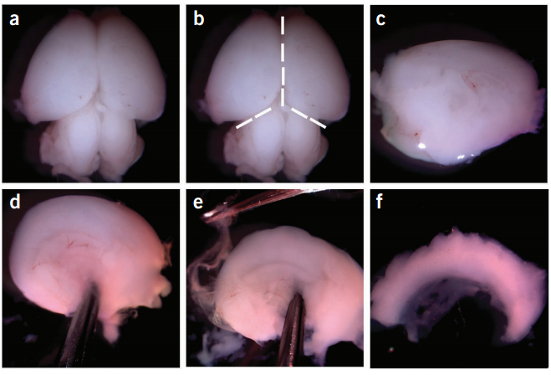
- By using forceps, pin down the anterior cortex.

(a) Place the brain dorsal side up in dissection medium. (b) Separate the hindbrain region and make a sagittal incision to separate the two hemispheres. (c) Place each hemisphere’s cortex side down and remove any noncortical forebrain tissue. (d) Hold the hemisphere in place using forceps; use caution so as not to damage the hippocampus. (e) Remove the meningeal tissue with another pair of forceps. Dissect out the hippocampus (f) and the cortex.

- Cell dissociation and plating
Transfer the tissue into a 50ml centrifuge tube only containing Hibernate to wash 1 time , then discard the supernatant. Add 6-10ml 0.125% Typsin/ HBSS (usually 6ml HBSS for 6 hippocampus), then incubate in 37 ℃ wate r bath for 15-20 min.
- Terminate the digestion by adding 1ml DMEM/F12 containing 10%FBS.Settle down 1min.
- Centrifuge the cells at 800 rpm , 5-10min and discard the supernatant.
- Dissociate the cells by trituration with a pasteur pipet(usually 8-15 times, slowly and gently do it) of DMEM/F12 containing 10%FBS.Filterize the cell supernatants by a 70um cell strainer.
- Take a 10µl aliquot of the dissociated cells to estimate viable cell density on a hemocytometer. Count cell numbers(1~2×10⁵/well).
- Then plating the neurons and incubate in the cell culture incubator at 37 °C .
8. Change to the maintenance medium about 3-6 hours after plating.
Maintenance of neurons ●timing up to 28 d
Twice a week, aspirate 30-50% the medium from each well/time-lapse dish and replace it with fresh maintenance medium warmed to 37 °C. These neurons can be maintained in culture for up to DIV 28.

Medium composition
